2025-2026 CEC Bright Ideas Grant Application

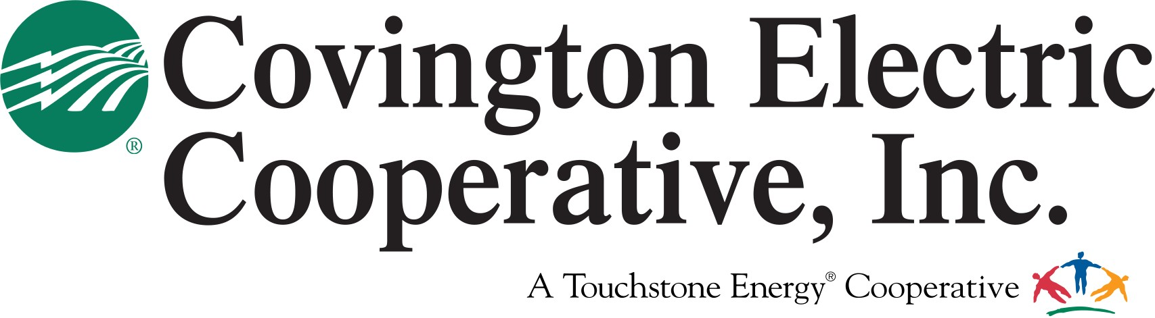

**To be considered for the Bright Ideas Grant Program, complete the following application. Applications must be postmarked by Nov. 3, 2025.**

1. **Only individual teachers may apply for funds up to $800**. Team grants are no longer available.
2. The principal's signature is required on the hard copy that is sent to CEC. Please keep a copy for your records.
3. Only one application per project per school will be considered. Project **MUST BE HANDS ON AND HIGHLY INTERACTIVE.**
4. Proof of project/program completion is required by the end of the school year. Proof of completion can be submitted by recipients through photographs or visits by CEC employees and trustees.
5. **Grants will not be awarded for any equipment or capital investments** (ex: iPads, tablets, computers, printers, projectors, playgrounds, chairs, tables, décor, computer programs, etc.)

**Mail completed application to: Or for more information contact:**

Covington Electric Cooperative https://covington.coop

Attn: Patty Singleton-Seay (800) 239-4121 Ext. 3508

Ref: Bright Ideas Program (334) 427-3508

18836 US Hwy 84 [psingleton@covington.coop](mailto:psingleton@covington.coop)

Andalusia, AL 36421

**Applicant Name:**

**School Name:**

**Daytime Phone:**

**School Phone:**

**School Address: City:**

**State:**

**Zip:**

**Home Address:**

**City:**

**State:**

**Zip:**

**Primary E-mail Address:**

**Section A**

**Project/Program Name:**

**Number of students benefiting from the project/program:**

**Amount Requesting: $**

**Would you accept partial funding?:**

 **Yes ** **No**

**If so, what is the minimum amount needed to implement the project/program?: $**

**Will the items purchased with this grant be used for more than one school year?:**

 **Yes ** **No**

Project Summary (Describe creative, innovative, hands-on elements of the project in 200 words or less. Attach additional sheets if necessary.)

*Attach additional sheets if necessary for any questions in this section.*

**Section B**

Population (*Describe students to be served, including grade level (100 words or less)*

Goals (What are the goals or objectives of the project *(200 words or less)*

Needs & Benefits (How will the project address students' needs and provide ongoing benefits *(200 words or less)*

Evaluation (How will the project outcomes be evaluated *(100 words or less)*

How will the project be documented for CEC?

Have you ever received a Bright Ideas grant from CEC? **Yes No**

Have you received any other grant funding for this project? **Yes No**

**Section C**

I have read the guidelines and agree to the terms and conditions for the Bright Ideas Grant Program. Should I receive any monies from this program, I will adhere to the guidelines stated in this application.

Signature of Applicant:

Approval (please check):

This application has been reviewed and approved by the principal of this school.

This application is not a request money for salaries or professional development.

Signature of Principal:

Applications must be post-marked by **Nov. 3, 2025**

# Mail completed application to:

Covington Electric Cooperative Attn: Patty Singleton-Seay

Ref: Bright Ideas Program 18836 US Hwy 84

Andalusia, AL 36421

**Or for more information contact:**

(334) 427-3508 or (800) 239-4121 Ext. 3508

[psingleton@covington.coop](mailto:psingleton@covington.coop)

**Bright Ideas Grant Program 2025-2026**